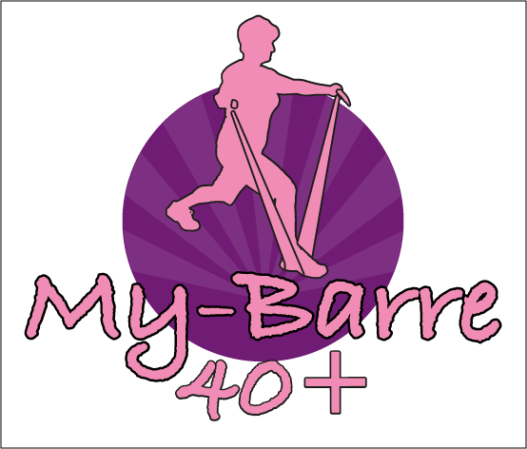
Exercise is safe. However, follow a few safety recommendations can help you stay injury free and active. Prior to starting an exercise program, the safety recommendations list below should be reviewed
You should speak to his/her doctor or health care provider before initiating an exercise program you have any concerns.
- If you have any of the symptoms listed below, medical advice/attention should be sought.
- If the you experience chest pain/pressure, trouble breathing or shortness of breath, light-headedness or dizziness, or nausea during exercise stop and see a doctor
- Activities inducing sharp pain should be avoided.
- If the you are really tired or has severe discomfort (some soreness is normal), you should slow down and take it easier.
- Exercise that causes increased joint pain should be avoided.
- Proper breathing is imperative during exercise. never hold your breath while exercising or straining, breath gently
- My-Barre is an exercise plan that considers older adults physical ability and activity level
- Start slowly, especially if you have not been physically active for a long time. Progressively build up physical activity.
- Unless otherwise directed by a doctor, make sure you drink plenty of fluids Even if you are not thirsty your body may need the extra fluids.
- Exercise should be slowed down and in a ventilated cool room during the hottest times of the day.
- Before stretching, a good warm-up that increases the heart rate and loosens up the muscles is imperative, so please ensure you attend early and do not leave early.

